**Lab Record**

**18CSC303J - DATABASE MANAGEMENT SYSTEM**

**B. Tech CSE - 3rd Year/6th Semester**

**Name :**

**Registration Number:**

**Submitted to : Ms. Vinam Tomar**

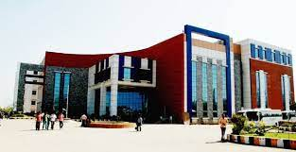

**DEPARTMENT OF COMPUTER SCIENCE AND ENGINEERING**

**SRM INSTITUTE OF SCIENCE AND TECHNOLOGY**

**NCR CAMPUS, DELHI MEERUT ROAD, MODINAGAR**

**GHAZIABAD(U.P) - 201204**

**Even Semester (2022-2023)**

**SRM INSTITUTE OF SCIENCE AND TECHNOLOGY**

**DEPARTMENT OF COMPUTER SCIENCE AND ENGINEERING**

**BONAFIDE CERTIFICATE**

**Registration no**- ____________________

Certified to be the bonafide record of work done by **______________________** of 6th semester 3rd year. B. Tech degree course in SRM IST, NCR Campus of Department of Computer Science and Engineering, in **Database Management System Laboratory** during the academic year 2022- 2023(Even)

**Lab In-Charge Head of the Department**

Submitted for external examination held on date ___/___/___ at SRM IST, NCR Campus

**External Examiner I External Examiner II**